Image Factory CLI (Command Line Interface)

- What is Image Factory CLI ?

imgfac.py it's a tool used for creating and customizing OS images for private and public clouds. It has two use cases, one to launch a daemon to provide a QMFv2 interface that other applications can use for building images and instantiate this images on the supported clouds, and the second, to create a single image in the supported clouds, using command line parameters. Currently the supported cloud services are:
public - Amazon EC2, Rackspace.
private – RHEV-M, KVM.

For a complete list of arguments, please consult the man page.

- What's the structure ?

To understand the flow of the CLI internals, we should start with a directory tree diagram of Image Factory:
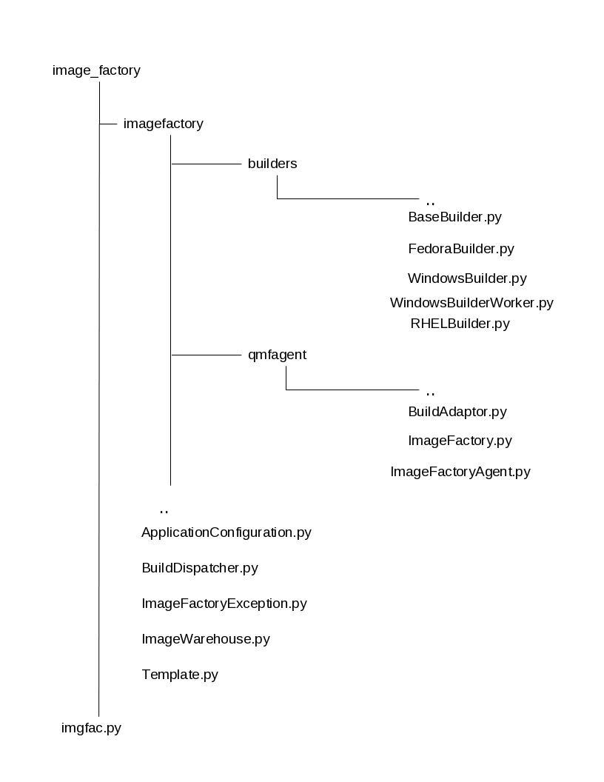

3. What are the modules ?

imgfac.py – command line script
ApplicationConfiguration.py – argument parser and help info
BuildDispatcher.py – detects and sends work to appropriate builder. If no builder is found, it will run the mock builder
ImageFactoryException.py – used to return messages (exceptions)
ImageWarehouse.py – used by image factory to store, fetch or remove information in Image Warehouse (templates, images, icicle...)
Template.py – reads the TDL template (passed as XML string, UUID, URL or XML file) and extracts the field values.
BuildAdaptor.py – builds images requested trough QMFv2 interface
ImageFactory.py – instance of Image Factory
ImageFactoryAgent.py – QMFv2 agent handler
BaseBuilder.py – main class for building images
FedoraBuilder.py – subclass of BaseBuilder.py that builds Fedora images
WindowsBuilder.py – subclass of BaseBuilder.py that builds Windows images
WindowsBuilderWorker.py – called by WindowsBuilder.py to build and customize images in public cloud providers.
RHELBuilder.py – subclass of BaseBuilder.py that builds RHEL images.

4. How to use it ?

- starting a QMFv2 agent handler thread. The agent uses an Image Factory singleton to manage BuildAdaptor instances
launching as daemon ./imgfac.py --qmf or in foreground --foreground

- build a placeholder image object on the local filesystem (this object will be used as input to build the image in the cloud service)
./imgfac.py --template TDL --target CloudProvider

- build images in the cloud service
./imgfac.py --image UUID --provider CloudProvider --credentials XML

5. How does it work ?

./imgfac.py --qmf

the argument --qmf will be read by ApplicationConfiguration.py and a QMFv2 handler thread will be started using ImageFactoryAgent.py, to listen for requests. The incoming requests will be processed by ImageFactory.py (a single instance of Factory), and based on the arguments passed by requests, ImageFactory.py will invoke two methods build_image and push_image from BuildAdaptor.py.
build_image : requires two parameters, --template and --target, and will produce a placeholder object on the local filesystem, by default in “/tmp”. A specific location can be provided by using --imgdir argument.
--template: an XML string, file or URL containing OS to build specifications
--target: a cloud service to use eg. ec2
push_image : requires three parameters, --image, --provider and –credentials, and will build the actual OS image in the specified provider cloud.
--image: the object's UUID created by build_image
--provider: the target region, eg. ec2-west in ec2 case. If the cloud service has no regions, provide the same value as for –target
The BuildAdaptor.py is the module that separates the QMF interface from the Builders. From this point on the flow will be the same as for the “one-off-builds” described next.

./imgfac.py --template TDL --target CloudProvider --imgdir /foo

The arguments are read by ApplicationConfiguration.py and the BuildDispatcher.py will be executed. BuildDispatcher.py will send the template to be read by Template.py and get back an XML string that is used to determine which Builder to execute. The appropriate Builder is called and build_image method will be executed, which will create the placeholder object and store it on the local filesystem.

./imgfac.py --image UUID --provider CloudProvider --credentials XML

The arguments are read by ApplicationConfiguration.py and the BuildDispatcher.py will be executed. BuildDispatcher.py will send the template to be read by Template.py and get back an XML string that is used to determine which Builder to execute. The appropriate Builder is called, the credentials are read, and push_image is executed, which is specific to the OS being built.
The common operations executed in push_image are: creating an OS instance, customize it by installing packages and create an image from the instance.

Reference documents to consider:

Image Factory Architecture document:
http://www.aeolusproject.org/page/Image:ImageFactoryArch.odt

Builder Classes:
http://www.aeolusproject.org/page/Builder_Classes

QMF:
https://github.com/aeolusproject/image_factory/blob/master/Documentation/QMF.markdown

The diagram below is showing the flow for all components of Image Factory.
